

|  |
| --- |
| **Member Compliance** |
| Solution Design Document |



**Table of contents**

Chapter 1 – Journey Overview and Prioritization 1

Chapter 2 - Member Compliance - Preferred Reality Technology 1

2.1 Design Constraint & Dependencies & Assumptions 1

2.1.1 Design Constraints 1

2.1.2 Dependencies 1

2.1.3 Assumptions 1

2.2 Identified Risk and Mitigation 1

2.3 Key Non-functional Requirements 1

2.4 Technology components 1

2.4.1 List of Technology Components 1

2.4.2 Technology Components Design 1

2.4.3 UI Component 1

2.4.4 API Gateway 1

2.4.5 Micro Services 1

2.4.6 Message Bus 1

2.4.7 Event Bus 1

2.4.8 Database 1

2.4.9 BPM and Workflow Approval 1

2.4.10 Document Management Solution 1

2.4.11 Common Services 1

2.5 Micro services 1

2.5.1 List of Micro Services <with endpoints and API contracts> 1

2.6 Data Architecture <all DB Entites and detailed schema> 1

2.6.1 Data Model 1

2.6.2 Data Migration 1

2.7 Object Model 1

2.7.1 Domain Object Model 1

2.7.2 Common Object Model 1

2.8 Data Validations 1

2.9 Business Rules 1

2.10 Sequence Diagrams for Key Business Process Flows of the Journeys 1

2.10.1 Change in Director – Auto Populate Member Contact Address 1

2.10.2 Change in Director – Document Upload Flow 1

2.10.3 Change in Director – Workflow Approval Process Flow 1

2.10.4 Change in Director – Notifications – Send SMS Flow 1

2.10.5 Change in Director – Billdesk Payment Flow 1

2.11 Logging 1

2.12 Error and Exception Handling 1

2.12.2 Error and Exception Handling in UI 1

2.12.3 Error and Exception Handling in Micro Services 1

2.13 Auditing 1

2.14 Caching 1

2.15 Integration Interfaces 1

2.15.1 Integration Flows 1

2.15.2 Interface List <with all other systems> 1

2.15.3 Integration with ENIT 1

2.15.4 Third Party Integration <incl. all Fintechs> 1

2.16 APIs Exposed For API Channel Interface 1

2.17 Security Design 1

2.17.1 Transport Security 1

2.17.2 Data Security 1

2.17.3 Authentication 1

2.17.4 Authorization 1

# – Journey Overview and Prioritization

Trading members of the Exchange are required to comply with requirements as laid down in Rules, Regulations and Byelaws of the Exchange and the Clearing Corporation (NSE Clearing).

Each Trading Member shall establish, maintain, and enforce procedures to supervise its business and to supervise the activities of its employees that are reasonably designed to achieve compliance with the NSE Bye-laws, Rules and Regulations and any notifications, directions etc. issued thereunder as well as the relevant statutory Acts.

There are 32 compliance sub-process which a member has to abide by. We have started with “Change in director”.

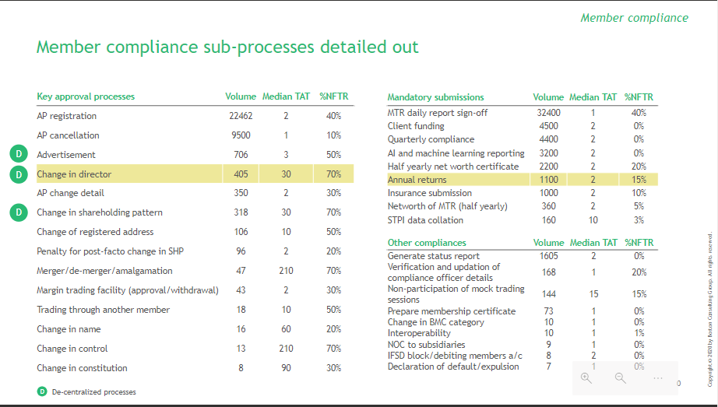

**5.2 Change in Director**

As per SEBI circular No: SEBI/MIRSD/Cir. No.03/2010 dated January 21, 2010 and SEBI Circular No: CIR/MIRSD/2/2011 dated June 03, 2011, members are required to obtain “fee clearance” for change in director(s) and “prior approval” for change in designated director(s).

* Application from member for changes can be received in Hard Copy or Soft Copy i.e. documents can upload under the path (ENIT> Document repository).
* If the uploaded documents are with digitally signed option, same can be considered for processing otherwise hard Copy will be required.
* There are different categories of Change in Director as,
  1. Incoming DD
  2. Incoming NDD
  3. Resigning DD
  4. Resigning NDD
  5. DD to NDD
  6. NDD to DD
* *DD – Designated Director, *NDD – Non-Designated Director

We have selected the incoming Designated Director process since it has most number of documents and most checks.

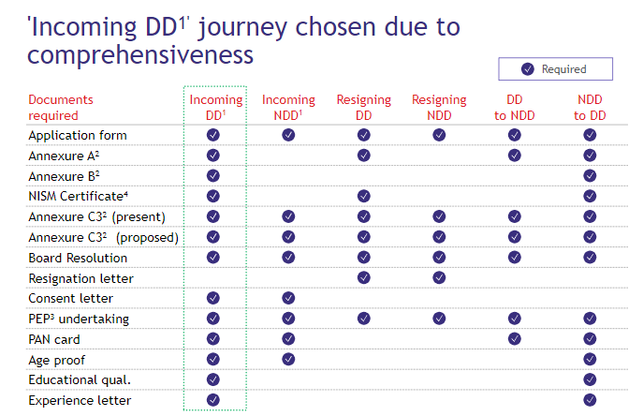

**5.3 Incoming Designated Director as-is process:**

1. **Document Submission:** 
   1. A member has to log in to the exchange website and download the application form
   2. A member has to fill that form and submit it to RO (Regional Officers) along with supporting documents.
   3. Inward - The details of document are captured in Membership Database > Application Status and an Excel sheet – MIS maintained at RO.
   4. Pain points:
      1. There are around 110 fields which need to be filled manually.
      2. There are lots of duplication in the fields.
      3. A member has to submit 13 documents for submission.
      4. There are digital signature issues.
2. **Document verification:**
   1. Once documents are received the checklist is manually verified.
   2. Detailed scrutiny - The detailed scrutiny of the application is carried out with respect to the following areas-
      1. Application made in prescribed format
      2. Confirmations of the member is received as per Annexure A
      3. Annexure B and Additional details of any new (incoming) director/s as per Annexure B is enclosed-
      4. Certified true copies of proof of age and educational qualification, experience certificates (applicable in case of incoming designated directors) -(all directors to be not less than 21 years of
      5. Age and designated director should have minimum education as HSC pass and should have a minimum of 2 years’ experience in an activity related to capital market.
      6. Whether certified true copy of Certificate of pass pertaining to any one designated director (existing in the proposed list of directors) or compliance officer pertaining to either NCFM/ NISM is given by the member
      7. Details of present directors as on ________ {date of application} As per Annexure C-3 duly certified by C.A/C.S. given by the member
      8. Details of proposed list of directors as on ________ {date of application} As per Annexure C-3 is given by the member
      9. Filling of checklist – After scrutiny of the documents, the checklist needs to be filled and printout of the same needs to be attached with the application. The maker checker procedure is followed.
      10. Pain points:
          1. Manual verification of documents
      11. Post that the application verification takes place
   3. Intimating deficiencies:
      1. If there are any deficiencies, then an email is sent to the member and member has to provide clarifications for the same.
      2. The member needs to be intimated about the deficiencies if any in the application submitted or for observations found during Name Search Process.
      3. In case member has made post facto changes, then show because letter is issued to the member.
      4. No penalty to be charged for approval of post-facto changes.
      5. Pain points:
         1. There are lots of deficiencies raised because of missing documents, missing fields, errors because lots of manual process.
         2. Low FTR (First time right) applications.
      6. After receiving the clarifications from the members, application is again sent back to RO.
      7. Then the member has to submit the reply for that show cause notice back to RO.
      8. Pain points:
         1. There is a separate process for getting clarifications from members.
         2. Show because notice is prepared and sent in hard copy format.
   4. NOC check:
      1. NOC request is raised in NOC database.
      2. RO has to manually type all the details of incoming designated directors in excel and that is then sent to NOC system to get NOC.
      3. Obtain NOC - NOC is to be obtained from Inspection, Investigation and ISC Departments.
      4. The NOC department gives approval.
      5. Pain points:
         1. The three departments (Inspection, Investigation and ISC Departments) manually check for complaint or proceedings against the member in their particular system.
      6. If any objection is raised then the clarification is sought from the member.
   5. SEBI fee clearance check:
      1. SEBI fee clearance is checked and if there are any pending dues then the members will be informed about the same.
      2. Pain points:
         1. Separate communication is sent for SEBI fee clearance.
         2. Lots of email threads.
      3. After that the settlement of dues takes place.
      4. Then the finance team of exchange confirms the debit with RO.
3. **Prior approval stage:**
   1. Preparation of approval note - The internal note is prepared
   2. Pain points:
      1. Manual preparation
      2. Checking and approval of notes takes 45 minutes per check.
   3. Intimation to the member – After approval has been obtained, the member needs to be intimated about the “prior approval” granted via letter.
   4. Updation of MDB -Membership database needs to be updated with proper remarks for approval granted to member under Director Tab.
   5. Also update details in Compliance Inward Master module for processing fee to be charged to member for approval granted.
   6. The Prior approval is granted by the Membership Compliance team after analysis of the application.
   7. Pain points:
      1. All documents are collected manually and stored in files/database
      2. MIS excel is used to store the process details and records.
      3. Everything is manual in this step
4. **Post implementation:**
   1. This is the last check which happens about 180 days after the letter is granted for the post implementation check.
   2. A member can choose whether he needs an extension to implement the changes after 180 days or not.
   3. If a member opts for an extension then he has to submit the extension letter to RO. After that RO grants extension.
   4. If member chooses not to opt for extension then he submits various documents required for final change to RO. After that membership database gets updated with remarks against that particular member.
   5. Pain points:
      1. No active tracking of members after 180 days
      2. Annexure 3 is asked for third time in the whole process

**5.4 The Re-imagined “change in director” process**

1. **Request selection and form filling: (Trading member)**
   1. Applying on member portal:
      1. Member will select “Change in director” under compliance
      2. Member will choose “Incoming DD” from 6 different categories (member can select multiple categories)
   2. Guidelines:
      1. Member can read entire process requirements and guidelines before processing with the application
      2. Member will verify the 'contact details' and 'compliance officer details' (which will be pre-populated from MDB) for communication - editable details
   3. Basic details filing:
      1. Member will fill basic details like name, PAN number, contact number, DIN of incoming DD
      2. Member can select educational qualifications from drop-down
      3. Member will fill experience details like total experience in years, start month/year, end month/year etc.
      4. Auto-verification through PAN validation (Name and DOB with PAN no. validation) through API integration
      5. Experience in no. of years will be auto calculated to establish minimum experience criteria (<2 years)
2. **Document upload: (Trading member)**
   1. Member will upload following documents in document upload tab.
      1. Experience letter
      2. Board resolution
      3. Templatised consent letter consent letter
   2. There will be a online sample showcase for experience letter to summarize the checklist of details needed (template can be provided)
   3. OCR/NLP will be used to read and validate experience letter details through key word searches (From year to year, for/in "company", as a "XX")
   4. OCR/NLP will be used to read and validate board resolution through key word searches (Name of the director, designation)
   5. Template letter will be auto-sent to e-mail ID of DD for consent through e-sign (can do aadhar based also)
3. **Director list summary: (Trading member)**
   1. Member will be able to view summary of all existing director details (Auto-populated from MDB) and new details (Auto-populated from basic details)
   2. This detail will have fields like name, PAN, DIN, contact no, DD/NDD etc.
   3. Member will have ability to add, edit and delete existing director details in case of outdated information being reflected
   4. Post-facto change:
      1. Answers if the change is post-facto
      2. If yes, selects the date of change
      3. Fills the clarification for post-facto
4. **Application submission: (Trading member)**
   1. Member will provide self-declaration for abiding with various declarations (includes SEBI fit and proper check guidelines and PEP undertaking) by selection (no text)
   2. Hassle free process for member by obtaining one e-sign from authority at the end
   3. E-sign/Digital signature of authorized signatory will be used for application submission
   4. SEBI fee clearance:
      1. Auto-intimation of pending SEBI dues payment by pulling data from FSR in old ENIT
      2. Option to directly pay on portal through integrated payment gateway
      3. Background verification through Fintech enabled APIs
5. **Application verification: (NSE)**
   1. Exchange office will perform a quick check on experience letter, board resolution letter
   2. Exchange officer will manually reviews the post-facto clarifications provided by member
   3. Display of background check results for maker to review (output as received by API integration)
6. **Communications module: (NSE and Trading member)**
   1. Deficiency raised by exchange officer after review to member
   2. Member's revert to exchange officer's deficiencies
   3. Notification is sent to both exchange officer and trading member
   4. Notification bar to enable member and exchange officer to view responses
   5. In case a person is away from portal then there will be provision to send E-mail alerts to contact person
7. **Prior approval: (NSE)**
   1. The prior approval letter will be auto-generated (checked online by exchange officer with option to accept and proceed) and it will be available to download
   2. There will be a standard template which can be auto filled with details from application and system
   3. SMS will be automatically generated and will be sent to registered mobile no. of compliance officer as confirmed earlier in the application
   4. Then in-case of post-facto, Warning letter will be auto-generated which will state that non-compliance in future can lead to disciplinary actions
8. **Dashboard: (NSE and Trading member)**
   1. There will be a main dashboard which will enable different compliance processes. For ex. 'Change in director' request for member
   2. A new real-time status dashboard will be created for the member to enable member to track the application progress
9. **System updation: (NSE)**
   1. Digital MIS will be created (with time-stamps and records of the application) and it will be integrated with MDB
10. **Invoice generation: (NSE)**
    1. The invoice will be generated automatically and will be sent to member by auto-calculating processing fees after prior approval grant
11. **Post-implementation: (NSE)**
    1. Reminders will be auto-sent after 180 days for member to confirm change
    2. In case of change, exchange officer will use API to pull data from MCA and verify directly form MCA.

# - Member Compliance - Preferred Reality Technology

## **Design Constraint & Dependencies & Assumptions**

### Design Constraints

### Dependencies

### Assumptions

## **Identified Risk and Mitigation**

## **Key Non-functional Requirements**

1. **Work in Progress – To be included in next draft**

## **Technology components**

### List of Technology Components

|  |  |  |  |
| --- | --- | --- | --- |
| **S.No** | **Area** | **Decision** | **Rationale** |
| 1 | Front end – web | **Angular** | Angular is better from a security perspective. It has better support for 12 factor coding standards. |
| 2 | Front end –mobile | **Reactnative** | Performance and user experience of React Native for mobile app development is better. |
| 3 | API Gatewway | **Apigee** | Apigee is better from the code flexibility, OOB policy availability, etc. |
| 4 | Micro Services | **Springboot** | Springboot is a widely accepted Java development framework for microservices. It integrates well with other components. |
| 5 | Event Broker | **Kafka** |  |
| 6 | Cache | **Redis** | Redis is widely used. |
| 7 | Database - Structured data | **Oracle** | Pre-existing at NSE |
| 8 | Data Security | **Vormetric** | Pre-existing at NSE |
| 9 | BPM and Workflow | INM Servicenow |  |
| 10 | SMS,OTP | Vodafone OTP Server | Pre-existing at NSE |
| 11 | SMTP Service | Microsoft SMTP Server | Pre-existing at NSE |

### Technology Components Design

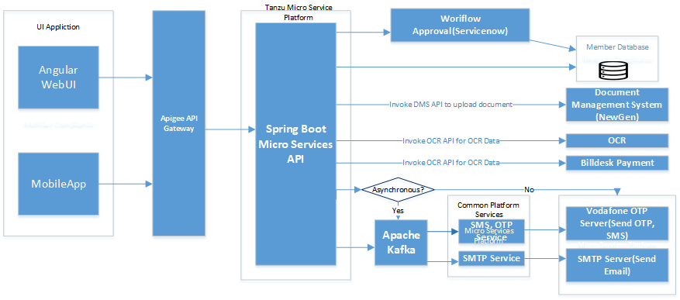

**Work in progress = To be furnished in next draft version**

### UI Component

### API Gateway

### Micro Services

### Message Bus

### Event Bus

### Database

### BPM and Workflow Approval

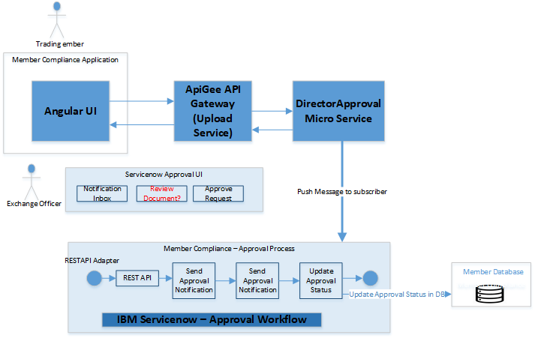

### Document Management Solution

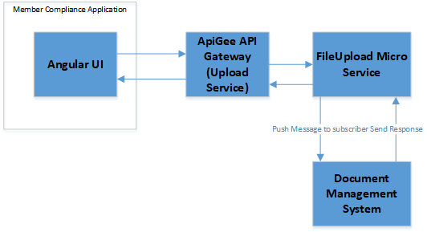

### Common Services

#### Send OTP Notification

#### Send SMS Notification

#### SMTP Service

#### Email Service

#### Payment Services & Background Verification & PAN Verification to be draft

## **Micro services**

|  |  |  |
| --- | --- | --- |
| **Microservice** | **Description** | **Dependencies** |
| Auto pull from MDB | Develop API to fetch compliance officer details from MDB. | Internal |
| Document upload | Develop API for Member to upload experience letter, board resolution letter and consent letter | Internal |
| PAN card verification | API integration with Fintech for PAN card detail verification | External |
| Experience check | Develop API to check whether member is satisfying minimum experience criteria | Internal |
| OCR/NLP for experience details | API integration with OCR to read and validate experience letter details through key word searches (From year to year, for/in "company", as a "XX") | External |
| OCR/NLP for board resolution | API integration with OCR to read and validate board resolution through key word searches (Name of the director, designation) | External |
| Template letter auto-sent to RMN/e-mail ID of DD for consent through e-sign (can do aadhar based also) | API integration for e-signing with Fintech and getting template to attach back in form after signing | External |
| Auto-populate existing director details | Develop API to auto populate director details from MDB | Internal |
| E-sign/Digital signature of authorized signatory | API integration with fintech for e-signing with Fintech to take digital signature by creation of string of form | External |
|  |  |  |
| Auto-intimation of pending dues | Develop API to auto intimate the pending SEBI dues by pulling data from FSR | Internal |
| Payment gateway | API integration with payment gateway to pending SEBI dues payment | External |
| Background verification | API integration with Fintech to do instant background verification of incoming director | External |
| Notification bar to enable member and exchange officer to view responses | Develop API to show notifications to the member and exchange officer | Internal |
|  |  |  |
| E-mail alerts | Develop API to send alerts on email | Internal |
| Auto generation of Prior approval letter | Develop API to auto generate the prior approval letter | Internal |
| SMS alerts | Develop API to auto generate the SMS and send to compliance officer’s mobile number | Internal |
| Main dashboard | Develop API Integration with central application | Internal |
| A real-time status dashboard | Develop API to enable member to track the application progress | Internal |
|  |  |  |
| Invoice generation | Integration with fintech to Auto-generate the invoice by auto-calculating processing | External |
| Creation of digital MIS with time-stamps and records of the application - integrate with MDB | Develop API Integration with MIS and MDB | Internal |
| Auto-storage of application and supporting documents in a document management system (tech team to evaluate) | Develop API Integration with Document Management System (DMS) | Internal |

### List of Micro Services



#### Domain Services

##### Change in Director

**Service Optimization needs to be done for below Micro Services. Service and resource endpoint listed below contains information for user stories received till this date.**

|  |  |  |  |  |  |
| --- | --- | --- | --- | --- | --- |
| *S.No* | *User Story/Function* | *Service Name* | *Service Description* | *Resource Endpoint* | *API Spec* |
|  | *Request selection & guidelines* | *CIDService* | *Update Selected List from UI* | */UpdateCIDTypeSelect* | *Do we need to store the selection? Otherwise this endpoint may not be needed* |
|  | *Basic details - All ChangeType Scenario below* | *CIDService* | *This service to be used for all change Type to fetch list of Directors for Member* | */GetDirectorList* |  |
|  | *Basic details (Resigning DD, DD to NDD) - single request* | *CIDService* | *Get ApplicantName, Director Contact Detials, Age, PAN, DIN* | */GetDirectorDetails* |  |
|  | *Basic details (Resigning NDD) - single request* | *CIDService* | *Yet to receive user story* |  |  |
|  | *Basic details (NDD to DD) - single request* | *CIDService* | *Get ApplicantName, Director Contact Detials, Age, PAN, DIN* | */GetDirectorDetails* |  |
|  | *CIDService* | *validate DD not to be part of other Memebr in directory list* | */VaidateDDNotinOtherDDList* |  |
|  | *Basic details (Compliance officer & contact person details)* | *CIDService* | *Update Mobile No. and Email ID for Compiiance Officer, Contact Person* | */UpdateContactDetails* |  |
|  |  |  |  |  |  |
|  |  |  |  |  |  |

##### Annual Returns

|  |  |  |  |  |  |
| --- | --- | --- | --- | --- | --- |
| *S.No* | *User Story/Function* | *Service Name* | *Service Description* | *Resource Endpoint* | *API Spec* |
|  |  |  |  |  |  |
|  |  |  |  |  |  |
|  |  |  |  |  |  |
|  |  |  |  |  |  |

#### Common Platform Services

Below common services are only on assumption basis and this needs to be discussed and revised once we reach actual use case/story

|  |  |  |  |  |  |
| --- | --- | --- | --- | --- | --- |
| *S.No* | *Common User Story/Function* | *Service Name* | *Service Description* | *Resource Endpoint* | *API Spec* |
| *2* | *Send OTP to subscribed mobile number* | *OTPlstformService* | *His platform service will receive message from Kafka and invoke Vodagone OTP Server to send message* | */sendOTP* |  |
| *3* | *Send SMS to registered Mobile umber* | *SMSPlatformServie* | *This platform service will receive will receive message from Kafka and invoke Vodafone Server to send single or Bulk SMS* | */SendSingleSMS*  */SendBulkSMS* |  |
| *4* | *Send Email to recipients* | *EmailService* | *This platform service will receive message from Kafka and send single of bulk email to email recipients* | */SendSingleEmail*  */SendBulkEmail* |  |
| *5* | *Read OCR from PDF/images* | *OCRService* | *This service to be provided by Fin Tech as third party service and possible to have multiple resource endpoints for multiple set of documents* | *For Eg.*  */GetPANNumber*  */GetAdharNumber*  */GetSignature* |  |

## **Data Architecture**

*<Cover the following points – What are the different data domain models for these microservices? Which databases will be implemented? What are the key data entities and relationships for microservices?>*

### Data Model

*<Cover the following points – Database Objects Design and Table Schema for the Journey should be explained here. This will be called Target Application Database Design>*

### Data Migration

*<Cover the following points – Database names, Schema and Tables of the Existing Applications which need to be migrated to the Target Application Database Schema/Objects. Specify the table/column mappings details etc. Also specify the file format in which existing application team to prepare the extract. >*

## **Object Model**

### Domain Object Model

**Below Object model is applicable for Member Compliance only. This model needs to be sync up with overall object model and optimized**

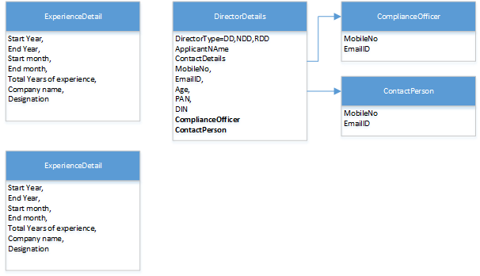

### Common Object Model

**Below Common Object Model is sample only. Separate workshop needs to be conducted to identify common object model**

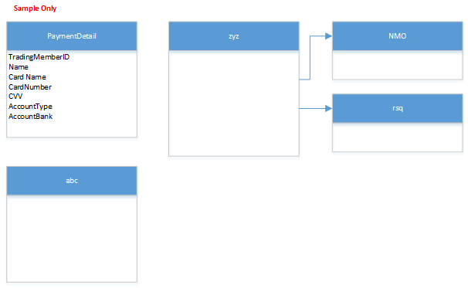

## **Data Validations**

*<Cover the following points – Refer user story/Epic Functional Flow output of Garage and specify data validations design>*

## **Business Rules**

*No Externalization of dynamic change of Business Rules applicable in Member Compliance Garage*

## **Sequence Diagrams for Key Business Process Flows of the Journeys**

*<Cover the following points – For the key process flows of this journey, how are the technical components (microservices/objects/other software components) across different architectural layers interacting with each other? >*

### Change in Director – Auto Populate Member Contact Address

|  |  |
| --- | --- |
| *S.No* | *User Story/Function* |
| *1* | *Verification of 'contact details' and 'compliance officer details' for communication - editable details pre-populated from MDB* |

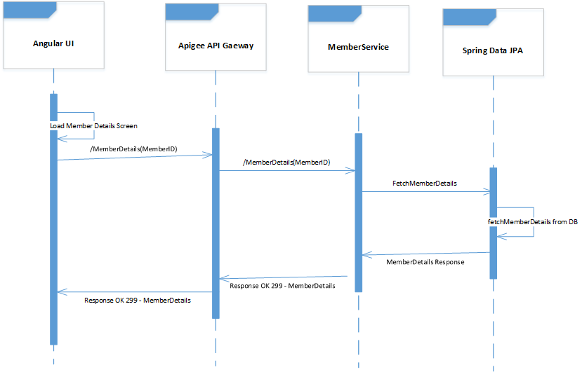

### Change in Director – Document Upload Flow

|  |  |
| --- | --- |
| *S.No* | *User Story/Function* |
| *1* |  |

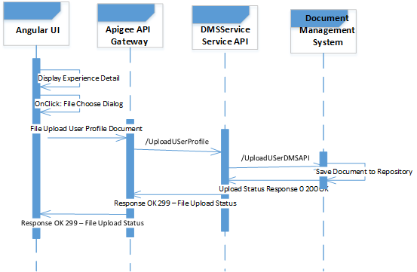

### Change in Director – Workflow Approval Process Flow

|  |  |
| --- | --- |
| *S.No* | *User Story/Function* |
| *1* | *Verification of 'contact details' and 'compliance officer details' for communication - editable details pre-populated from MDB* |

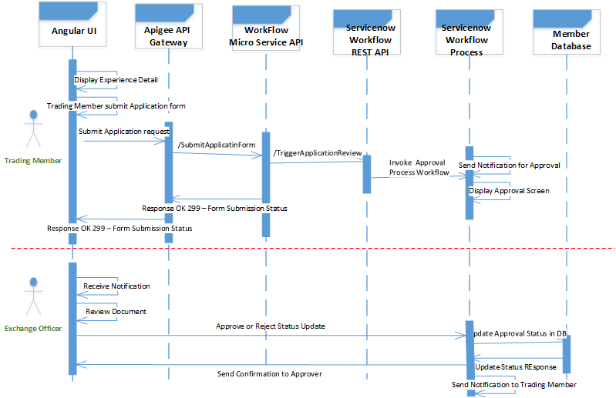Below section work in progress

Below section work in progress

### Change in Director – Notifications – Send SMS Flow

### Change in Director – Billdesk Payment Flow

## **Logging**

## **Error and Exception Handling**

*<Cover the following points – For the key process flows of this journey, what are the Exception Flows and List of Error Codes & Error Messages>*

#### System Exception

#### Business Exception

#### ErrorCodes

*– Include HTTP Error Codes*

*– Include Business Error Codes*

### Error and Exception Handling in UI

Elaborate How Exception is handled in UI

### Error and Exception Handling in Micro Services

## **Auditing**

## **Caching**

## **Integration Interfaces**

### Integration Flows

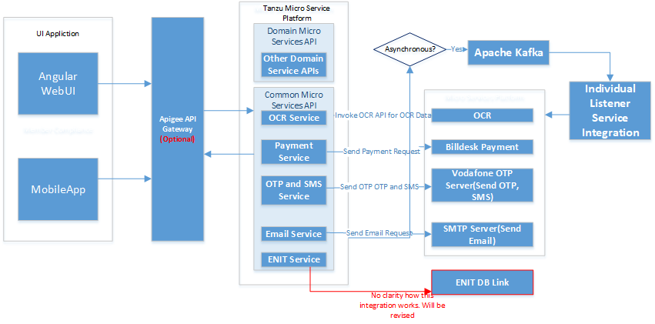

### Interface List

There is only one interface listed for Member compliance and having no clarity. This will be discussed and updated in next version.

|  |  |  |  |  |  |  |  |  |  |  |  |  |  |  |
| --- | --- | --- | --- | --- | --- | --- | --- | --- | --- | --- | --- | --- | --- | --- |
| ***Sr. No.*** | ***System*** | ***Market Segment*** | ***Incoming/ Outgoing*** | ***Push / Pull*** | ***Data Entity Exchanged*** | ***Interface Protocol*** | ***Message Format*** | ***Sync/ Async*** | ***Batch/ Real-time*** | ***Business event/ Time of invocation*** | ***Peak Rate*** | ***If multiple records, preak count*** | ***Data Size Exchanged*** | ***Description (Including other important details from interface)*** |
| 1 |  |  |  |  |  |  |  |  |  |  |  |  |  |  |
|  |  |  |  |  |  |  |  |  |  |  |  |  |  |  |
|  |  |  |  |  |  |  |  |  |  |  |  |  |  |  |
|  |  |  |  |  |  |  |  |  |  |  |  |  |  |  |
|  |  |  |  |  |  |  |  |  |  |  |  |  |  |  |
|  |  |  |  |  |  |  |  |  |  |  |  |  |  |  |
|  |  |  |  |  |  |  |  |  |  |  |  |  |  |  |

### Integration with ENIT

Need to discuss and get more clarity

### Third Party Integration

#### Payment Gateway Integration – BillDesk

#### Integration – PAN Verification

#### Integration – OCR

#### Integration – Vodafone (OTP, SMS)

#### Integration – SMTP Service

SMTP Server Details to be furnished

## **APIs Exposed For API Channel Interface**

*<Cover the following points – Refer user story/Epic Functional Flow output of Garage and specify APIs exposed and its detailed end points signatures for consumption of stakeholders e.g. Trading Members, Clearing Members etc>*

Yet to determine

## **Security Design**

**Discussion in progress and to be finalized. Update this section later.**

### Transport Security

### Data Security

**How to secure data with encryption, vormetric, tool usage, data masking etc..**

### Authentication

#### Authentication for Web

#### Authentication for API Gateway

#### Authentication for Micro Services

### Authorization

#### Authorization for Web

#### Authorization for API Gateway

#### Authorization for Micro Services